2014-2015学年度第二学期九年级英语练习

本试卷分为第Ⅰ卷（选择题）、第Ⅱ卷（非选择题）两部分。第Ⅰ卷为第1页至第8页，第Ⅱ卷为第9页至第10页。试卷满分120分。考试时间100分钟。
答卷前，请你务必将自己的姓名、考试号、考点校、座位号填写在“答题卡”上，并在规定位置粘贴考试用条形码。答题时，务必将答案涂在“答题卡”上，答案答在试卷上无效。考试结束后，将本试卷和“答题卡”一并交回。
祝你考试顺利！

第Ⅰ卷

注意事项：
1. 每题选出答案后，用2B铅笔把“答题卡”上对应题目的答案标号的信息点涂黑。如需改动，用橡皮擦干净后，再选涂其他答案标号的信息点。
2. 本卷共五大题，共80分。

一、听力理解（本大题共20小题，每小题1分，共20分）
A) 在下列每小题内，你将听到一个或两个句子并看到供选择的A、B、C三幅图画。找出与你所听句子内容相匹配的图画。
1. |  |  |  |  | 
 | A. |  | B. |  | C.
2. | 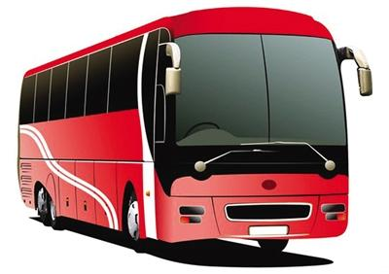 |  |  |  | 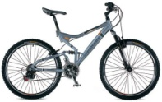
 | A. |  | B. |  | C.
3. |  |  |  |  | 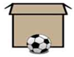
 | A. |  | B. |  | C.
4. | 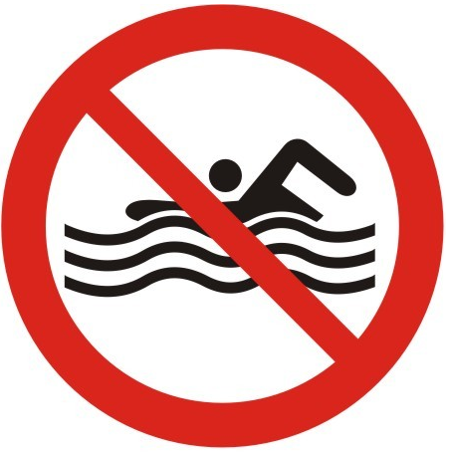 |  |  |  | 
 | A. |  | B. |  | C.
B)下面你将听到十组对话，每组对话都有一个问题。根据对话内容，从每组所给的A、B、C三个选项中找出能回答所提问题的最佳选项。
5. When will the plane take off?
A. At 10:20. B. At 10:40. C. At 20:10.
6. What was the boy’s father doing?
A. He was reading newspapers. B. He was working.
C. He was watching TV.
7. How much money has the project got?
A. More than 500, 000 yuan. B. More than 15,500,000 yuan.
C. More than 50,150, 000 yuan.
8. What are they talking about?
A. The morning. B. Reading. C. Learning English.
9. What can we learn from the dialogue?
A. The man talked to a visitor just now.
B. The woman told the visitor the way to the bus stop.
C. The woman didn’t know the way to the bus stop.
10. What would the woman like?
A. An apple. B. An orange. C. A banana.
11. What will the man do?
A. Smoke again. B. Stop smoking. C. Go fishing.
12. Who has brown hair?
A. Anna. B. Anna’s father. C. Anna’s mother.
13. Why doesn’t the man want more cakes?
A. Because he is full.
B. Because he doesn’t like cakes.
C. Because he wants to eat some bread.
14. Where will the beach party be?
A. By the trees. B. By the boats. C. At the coffee shop.
C) 听下面长对话或独白。每段长对话或独白后都有几个问题，从题中所给的A、B、C三个选项中选出最佳选项。
听下面一段材料，回答第15至第17题。
15. Why is John so excited?
A. Because he will go for a trip next Friday.
B. Because he will go to dinner with his friends next week.
C. Because he will go to see his parents next week.
16. Where is John going next week?
A. Hong Kong. B. The USA. C. England.
17. When is John going to leave?
A. On June 29. B. On July 29. C. On July 19.
听下面一段材料，回答第18至第20题。
18. What does the game help you to do?
A. To learn English. B. To do my homework. C. To answer questions.
19. What does the game begin with?
A. A little boy playing computer games.
B. A little girl sitting in the classroom.
C. A little boy dreaming on the grass.
20. Where can we get the game?
A. In a history book. B. At the police station. C. On the Internet.
二、单项填空（本大题共20小题，每小题1分，共20分）
从下列每小题所给的A、B、C、D四个选项中，选出可以填入空白处的最佳选项。
21. _____ best time to visit New England in a year is in _____ September.
A. /; the B. A; / C. A; the D. The; /
22. —The population of China is 1,370,530,000. But how to read the number?
—That is _____.
A. thirteen billion, seventy million, five hundred and thirty thousand
B. one million, three hundred and seventy thousand, five hundred and thirty
C. one billion, three hundred and seventy million, five hundred and thirty thousand
D. one billion, three hundred million, seventy hundred and fifty three thousand
23. You have to eat _____ chopsticks in a Chinese restaurant.
A. by B. with C. under D. against
24. This is a public park. _____ person may visit _____.
A. Any; it B. Some; it C. Any; them D. Some; them
25. You eat too much candy. It is _____ to your teeth.
A. helpful B. successful C. careful D. harmful
26. Ben _____ the famous painting somewhere. Nobody could find it.
A. practised B. hit C. covered D. hid
27. An earthquake happened _____ in Wenchuan on May 12th, 2008.
A. suddenly B. loudly C. immediately D. quickly
28. _____ Mary was doing her homework, her mother was cooking.
A. Because B. Although C. While D. If
29. Don’t make so much _____. I have a bad headache.
A. sound B. noise C. voice D. music
30. —Peter offered ______ us skating.
—That’s great! He is really good at it.
A. to teach B. teach C. teaching D. taught
31. —What _____ the accident?
—It was the bad weather.
A. cause B. caused C. will cause D. causes
32. —There are storms in winter in Texas _____.
—I think I should bring an umbrella every day.
A. in time B. in the end C. for the first time D. from time to time
33. —Why didn’t you go to Betty’s party yesterday evening?
—Because I _____ for my report.
A. am preparing B. was preparing C. will prepare D. prepare
34. She read the text loudly _____ all the students could hear her.
A. because B. since C. when D. so that
35. —Lingling hurt her knee in the training.
—_____.
A. Sorry B. What a surprise C. Perfect D. That’s too bad
36. The notice about the school-leavers’ party _____ soon on the wall.
A. is put up B. will be put up C. put up D. has put up
37. —Where are you going this winter holiday?
—I’m not sure. I _____ go to a warmer place in the south.
A. should B. must C. might D. need
38. —I don’t know _____.
—Maybe tomorrow.
A. when he is leaving B. why is he leaving
C. whether he is leaving D. what time is he leaving
39. Some of the words _____ Australians use are very different from the words used by Americans.
A. that B. what C. whose D. who
40. —Mum, I’ll have a very important exam today.
—Oh. _____!
A. Good luck B. Not at all C. Good idea D. Sorry
三、完形填空（本大题共10小题，每小题1分，共10分）


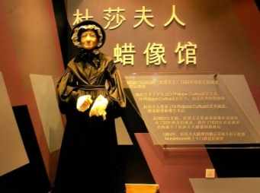

There are many places for people to visit in London. One famous place for 41 in London is Madame Tussaud’s museum (杜莎夫人蜡像馆). Here people can 42 figures (蜡像) of famous people made of wax (蜡).
Madame Tussaud was born in France in 1761. Her uncle, who was a doctor, made wax figures of people. He 43 a museum of these figures in Paris. Marie Tussaud helped him in his 44 .
In 1789, during the 45 Revolution (革命), Marie was sent to prison (监狱). Here she had to copy the heads of 46 people when they were dead, including King Lousis XVI’s and Queen Marie Antoinette’s.
In 1795, Marie 47 Francois Tussaud and in 1802 they came to London with her wax figures. Her figures can still be 48 today.

Nowadays, Madame Tussaud’s is opened in several 49 , such as New York, Hong Kong, Amsterdam (阿姆斯特丹) and Las Vegas (拉斯维加斯). People can visit Madame Tussaud’s not only in Europe 50 in Asia and America.
41. A. ladies B. students C. artists D. tourists
42. A. draw B. make C. see D. buy
43. A. visited B. opened C. closed D. repaired
44. A. museum B. hospital C. school D. factory
45. A. English B. Russian C. Chinese D. French
46. A. good B. beautiful C. famous D. tall
47. A. married B. encouraged C. found D. saved
48. A. made B. seen C. discovered D. stolen
49. A. towns B. villages C. cities D. states
50. A. and B. so C. or D. but
四、阅读理解（本大题共15小题，其中51-60题每小题2分，61-65题每小题1分，共25分）
阅读下面的材料，从每小题所给的A、B、C、D四个选项中选出最佳选项。
( A )
Day | Mike’s plan | Mary’s plan
Monday | study group meeting 3:00 p.m. | 7:00 p.m. go to the cinema with Alice
Tuesday | basketball match 4:30 p.m. | 10:00 a.m. see the doctor
Wednesday | go to see some friends 2:00 p.m. | evening — study for exam
Thursday | noon, lunch with Mary | 8:30 p.m. concert
Friday | 2:00-4:00 p.m. volunteer work at the student center | afternoon — help Uncle Sam in his restaurant
Saturday | shopping 10:00 a.m. | 9:00 a.m.-10:30 a.m. art class
Sunday | basketball team party 9:00 p.m. | 8:00 p.m. supper with Betty and Ann
51. Mike’s study group meeting will be on .
A. Sunday morning B. Monday afternoon
C. Saturday evening D. Friday afternoon
52. From Mike’s plan we learn that Mike likes playing .
A. table tennis B. football C. volleyball D. basketball
53. What will Mary do on Wednesday evening?
A. See her friends. B. Play basketball.
C. Go to her art class. D. Study for an exam.
54. Who will Mike have lunch with on Thursday?
A. Betty. B. Ann. C. Mary. D. Uncle Sam.
55. Mary will at 8:30 p.m. on Thursday.
A. go to the concert B. be free C. see the doctor D. go shopping
( B )
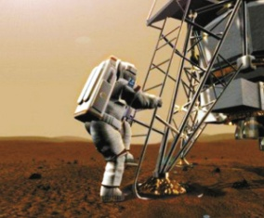
MANY 15-year-olds don’t know what they want to be when they grow up. Abby Harris knows she wants to become an astronaut and isn’t letting anything stop her.
According to Harris’ Internet blog, Astronaut Abby, she has wanted to be the first astronaut to walk on Mars since she was 5 years old.
Harris wrote that at the beginning. Most people didn’t take her dream seriously. But she stuck with (坚持) it.
“I made plans, I worked hard and I focused on (集中于) my goal. As I got older and continued to stay focused on science, people in my life began to notice and encouraged me to dream big,” she wrote.
In the 7th grade, Harris was doing a project on the International Space Station. She set up a Twitter account to get in touch with NASA (美国航空航天局). But soon she found that it was a great place for her to write about her dreams and talk with others who are interested in space. Her friends on Twitter then helped her create her website and blog, Astronaut Abby.
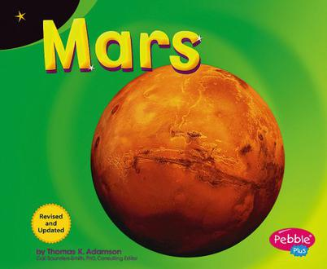
What’s more, Harris has a real astronaut as her mentor (导师). Several years ago, Harris ran into Italian astronaut Luca Parmitano at an airport. They talked for an hour and Parmitano agreed to become her mentor. Now Parmitano is in the International Space Station. Harris e-mails him every day to learn about his experiences.
It’s not easy to become an astronaut, but Harris is confident about herself.
“If you work really hard at something, it can happen. And it will happen,” she said.
56. Who is Abby Harris?
A. She is a five-year-old girl. B. She is a fifteen-year-old girl.
C. She is a girl in the 7th grade. D. She is the astronaut walking on Mars.
57. Which of the following of Abby Harris is TRUE?
A. She wants to be the first astronaut on the moon.
B. She has made plans to let her dream come true.
C. She is often laughed at for dreaming big.
D. She gave up her dream because it’s bad for her.
58. At first Abby Harris set up a Twitter account in order to _______.
A. learn more about space B. make more friends online
C. tell others about her dream D. introduce her website and blog
59. Where did Harris meet Luca Parmitano?
A. In Italy. B. In the street.
C. At an airport. D. In the International Space Station.
60. What does the story want to tell us?
A. Look before you leap (跳). B. Well begun is half done.
C. All roads lead to Rome. D. Where there is a will there is a way.
( C )

Around the world more and more people are taking part in dangerous sports activities. Of course, there have always been people who have looked for adventure and those who have climbed unknown parts of the world or sailed in small boats across the greatest oceans. Now, however, there are people who seek (寻找) a risky activity, which may only last a few minutes or even seconds.
Bungee jumping is a good example of such an activity. You jump from a high place 200 meters above the ground with an elastic (有弹力的) rope tied to your feet. You fall at up to 150 kilometers an hour until the rope stops you from hitting the ground. It is reported that two million people around the world have now tried bungee jumping.
Why do people take part in such activities like this? Some psychologists (心理学家) suggest that it is because life in modern societies has become safe and boring. In ancient times, people had to face danger and difficulties. They had to go out and hunt for food. Diseases could not easily be cured, and there was a continuous battle for survival (生存).
Nowadays, according to many people, life offers little excitement. They live and work in comparatively safe environments; they buy food in shops; there are doctors and hospitals to look after them if they become ill. It is necessary for some of these people to seek danger in activities such as bungee jumping.
61. Why do people tie their feet with an elastic rope in bungee jumping?
A. Because it’s more exciting. B. Because it’s interesting.
C. Because it can protect people. D. Because it’s very high.
62. How many people have tried bungee jumping?
A. More than 150. B. About 200.
C. Few people. D. 2,000,000.
63. In Paragraph 2, what does the underlined sentence mean?
A. Bungee jumping is a very popular activity.
B. Bungee jumping is a dangerous activity that only lasts a few seconds.
C. Bungee jumping is an activity that many people like very much.
D. Bungee jumping is an activity that is similar to sailing.
64. Which of the following is NOT true according to the passage?
A. People in ancient times could be looked after well.
B. People in ancient times had to hunt for food.
C. Today people’s life is safe.
D. Some people think that life today is boring.
65. What is the best topic (题目) of the passage?
A. How to Keep Fit B. Sports and Health
C. Sports Activities in History D. Dangerous Sports Activities
五、补全对话（本大题共5小题，每小题1分，共5分）
根据对话的内容，从方框中选择恰当的句子，将对话补充完整。（选项中有两项是多余的）

A. Thank you for answering my questions.
B. Where are koalas from?
C. What’s the weather like in Australia?
D. Do you have a pen pal?
E. Does Australia have any famous animals?
F. Where is she from?
G. She is tall and beautiful.

A: Excuse me. (66 )
B: Yes, I do. I have a girl pen pal.
A: (67)
B: She is from Sydney.
A: Where is Sydney?
B: It’s a city in Australia.
A: (68)
B: Yes. Koalas are from Australia. They sleep in the day and get up to eat at night.
A: That sounds interesting. And (69)
B: It’s warm in winter and cool in summer.
A: (70)
B: You’re welcome.

2014-2015学年度第二学期九年级英语练习

第Ⅱ卷

注意事项：
1. 用黑色墨水的钢笔或签字笔将答案写在“答题卡”上。
2. 本卷共四大题，共40分。

六、完成句子（本大题共5小题，每小题2分，共10分）
根据所给中文意思完成句子，每空限填一词。
71. 学生们正在静静地听老师讲课。
The students are listening to the teacher ________ ________.
72. 昨天，我从自行车上摔了下来，摔伤了胳膊。
I ________ ________ my bike and hurt my arm yesterday.
73. 踢球时要小心你的眼镜。
Be ________ ________ your glasses when you play football.
74. 我好几个月没有收到女儿的来信了。
I haven’t ________ ________ my daughter for months.
75. 上周老师和他们一起参加了训练。
The teacher ________ ________ in the training with them last week.
七、任务型阅读（本大题共5小题，每小题1分，共5分）
下面是某报纸上5篇文章的标题，请根据这些标题所提供的信息完成句子。

76. __________________ in India is on fire.
77. In Guiyang, the students don’t __________________ because of the flood (洪水).
78. __________________ get lost in Mount Tai.
79. Ted wins the 400-metre race. His result is __________________.
80. A girl is saved by __________________ in Xinjiang.
八、综合填空（本大题共10小题，每小题1分，共10分）
根据短文内容及首字母提示，填写所缺单词，使短文意思完整。每空限填一词。
Hello, everyone!
Thank you very much for coming to this concert. I hope you have e (81) the performance.
This concert is to r (82) money for children in Africa. Every day hundreds of children in Africa die because they don’t have enough to eat. There are two reasons. First, there is no work for the children’s parents. S (83), the governments in many African countries do not have the money to help the p (84).
Most African countries are poor. The land is not good for growing food and the weather is a (85) bad for farming. The Feed Africa Fund s (86) millions of dollars every year on food for poor people in Africa. This money comes from people l (87) you – kind and generous people. No one wants to see children die from hunger.
Every dollar you give this evening will go to the Feed Africa Fund. O (88) one dollar can buy enough food to feed a family of four for three days.
Please be kind and generous! Give your money w (89) a helping hand. Your money can make others’ life d (90). Thank you!
九、书面表达（本大题共15分）
91. 为了进一步增强中学生的安全意识，提高自我保护能力，学校即将开展以“安全”为主题的英语演讲比赛。请你根据以下要点提示写一篇演讲稿。
要点：1. 遇险报警
2. 慎重交友，不随便与陌生人交谈
3. 上网时，不要轻易告诉别人个人信息
4. 在校园内也要注意安全，避免意外事故
5. 请你补充一点
注意：1. 词数：80-100。
2. 短文的开头和结尾已给出，不计入总词数。
3. 短文须包括所有内容要点，行文连贯，表达清楚，书写规范。
参考词汇：casually随便地 stranger 陌生人 avoid避免
Dear friends,
As students, we should always keep safety in mind. But how can we keep safe?
________________________________________________________________________
________________________________________________________________________
________________________________________________________________________
________________________________________________________________________
That’s all. Thank you.

