2013年普通高等学校招生全国统一考试(辽宁卷)
英 语
本试卷分第一卷（选择题）和第二卷（非选择题）两部分。考试结束后，将本试卷和答题卡一并交回。
第一卷
注意事项：
- 答题前，考生务必将自己的姓名、准考证号填写在答题卡上。
- 选出每小题答案后，用铅笔把答题卡上对应题目的答案标号涂黑。如需改动，用橡皮擦干净后，再选其他答案标号，不能答在试卷上，否则无效。

第一部分 听力（共两节，满分30分）
做题时，先将答案标在试卷上。录音内容结束后，你将有两分钟的时间将试卷上的答案转涂到答题卡上。
- （共5小题：每小题1. 5分，满分7. 5分）
听下面5段对话。每段对话后有一个小题，从题中所给的A、B、C三个选项中选出最佳选项，并标在试卷的相应位置。听完每段对话后，你都有10秒钟的时间来回答有关小题和阅读下一小题。每段对话仅读一遍。
- What does the man want to do?
- Take photos B. Buy a camera C. Help the woman.
- What are the speakers talking about?
- A noisy night. B. Their life in town. C. A place of living.
- Where is the man now?
- On his way B. In a restaurant. C. At home.
- What will Celia do?
- Find a player. B. Watch a game. C. Play basketball.
05. What day is it when the conversation takes place?
A. Saturday. B. Sunday. C. Monday.
- （共15小题；每小题1. 5分，满分22. 5分）
听下面5段对话。每段对话后有几个小题，从题中所给的A、B、C 三个选项中选出最佳选项，并标在试卷的相应位置。听每段对话前，你将有时间阅读各个小题，每小题5秒钟，听完后，各个小题给出5秒钟的做答时间。每段对话读两遍。
听第6段材料，回答第6、7题。
06. What is Sara going to do?
A. Buy John a gift. B. Give John a surprise. C. Invite John to France.
07. What does the man think of Sara’s plan?
A. Funny. B. Exciting. C. Strange.
听第7段材料，回答第7、8题。
08. Why does Diana say sorry to Peter?
A. She has to five up her travel plan. B. She wants to visit another city.
C. She needs to put off her test.
09. What does Diana want Peter to do?
A. Help her with her study. B. Take a book to her friends. C. Teach a geography lesson.

听第8段材料，回答第10至12题。
10. Why does the man call the woman?
A. To tell her about her new job. B. To ask about her job program. C. To plan a meeting with her.
11. Who needs a new flat?
A. Alex. B. Andrea. C. Miranda.
12. Where is the woman now?
A. In Baltimore. B. In New York. C. In Avon.
听第9段材料，回答第13至16题。
13. What does Jan consider most important when he judges a restaurant?
A. Where the restaurant is. B. Whether the prices are low. C. How well the food is prepared.
14. When did Jan begin to write for a magazine?
A. After he came back to Sweden.
B. Before he went to the United States.
C. As soon as he got his first job in 1982.
15. What may Jan do to find a good restaurant?
A. Talk to people in the street. B. Speak to taxi drivers. C. Ask hotel clerks.
16. What do we know about Jan?
A. He cooks for a restaurant. B. He travels a lot for his work. C. He prefers American food.
听第10段材料，回答第17至20题。
17. What do we know about the Plaza Leon?
A. It’s a new building. B. It’s a small town. C. It’s a public place.
18. When do parents and children like going to the Plaza Leon?
A. Saturday nights. B. Sunday afternoons C. Fridays and Saturdays.
19. Which street is known for its food shops and markets?
A. Via del Mar Street. B. Fernando Street. C. Hernandes Street.
20. Why does the speaker like Horatio Street best?
A. It has an old stone surface. B. It is named after a writer. C. It has a famous university.

第二部分 英语知识运用（共两节，满分45分）
第一节 单项填空（共15小题；每小题1分，满分15分）
从A、B、C、D四个选项中，选出可以填入空白处的最佳选项，并在答题卡上将该项涂黑。
21. ---What do you think of the house?
---_____________. It’s everything we’ve been looking for.
A. Perfect! B. Good idea! C. Not bad. D. so-so.

22. He was unhappy when he sold his guitar. After all, he _________if for a very long time.
A. has had. B. had had C. has D. had
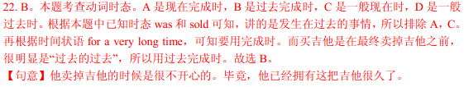
23. The accident caused some _______to my car, but it’s nothing serious.
A. harm B. injury C. ruin D. damage
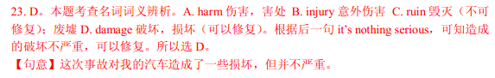
24. One can always manage to do more things, no matter________full one’s schedule is in life.
A. how B. what C. when D. where
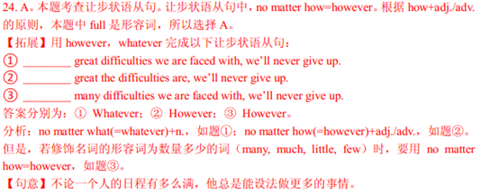
25. _______________everyone here, I wish you a pleasant journey back to your country.
A. By means of B. On behalf of C. In search of D. For fear of
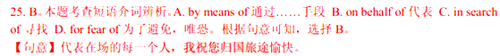
26. At no time ________the rules of the game. It was unfair to punish them.
A. they actually broke B. do they actually break
B. did they actually break D. they had actually broken
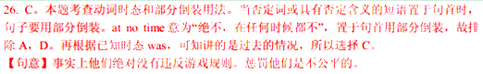
27. Everything seemed to be going __________for the first two days after I moved to New York.
A. vividly B. generally C. frequently D. smoothly
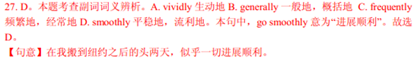
28. Laura was away in Paris for over a week. When she got home, there was a pile of mail ______for her.
A. waited B. to wait C. waiting D. was waiting

29. To her joy, Della earned first the trust of her students and then _____of her colleagues.
A. that B. one C. ones D. those
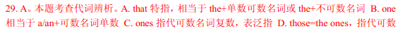

30. We are confident that the environment ______by our further efforts to reduce pollution.
A. had been improved B. will be improved
C. is improved D. was improved
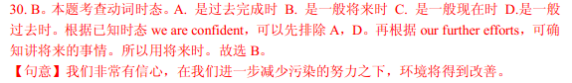
31. Harry is feeling uncomfortable. He _______too much at the party last night.
A. could drink B. should drink C. would have drunk D. must have drunk
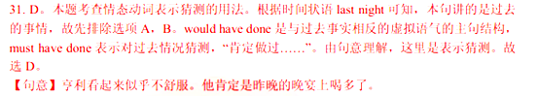
32. Briggs will ________as general manager when Mitchell retires.
A. get away B. take over C. set off D. run out
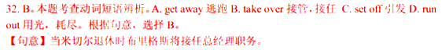
33. This is by far_______movie that I have ever seen.
A. an inspiring B. a much inspiring C. the most inspiring D. the more inspiring
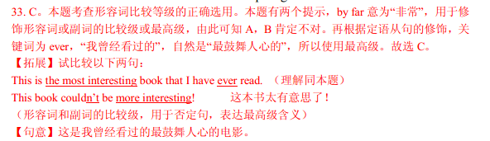
34. He may win the competition, ____________he is likely to get into the national team.
A. in which case B. in that case C. in what case D. in whose case
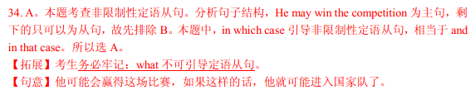
35. ---I’m afraid you have the wrong number.
--- Sorry!________.
- See you later B. I didn’t know that C. Hold on, please D. I hope I didn’t bother you

- 完形填空（共20小题；每小题1. 5分，满分30分）
阅读下面短文，从短文后各题所给的四个选项（A、B、C、D）中，选出可以填入空白处的最佳选项，并在答题卡上将该项涂黑。
A little girl lived in a simple and poor house on a hill. Usually she 36 play in the small garden. She could see over the garden fence and across the valley a wonderful house with shining golden windows high on another hill. 37 she loved her parents and her family, she desired to live in such a house and 38 all day about how wonderful and exciting 39 must feel to live there.
At the age when she gained some 40 skill and sensibility(识别力), she 41 her mother for a bike ride ___42 the garden. Her mother finally allowed her to go, 43 her keeping close to the house and not 44 too far. The day was beautiful. The little girl knew 45 where she was heading! 46 the hill and across the valley, she rode to the 47 of the golden house.
48 she got off her bike and put it against the gate post, she focused on the path _49 _ to the house and then on the house itself. She was very disappointed when she 50 that all the windows were 51 and rather dirty.
So 52 and heart-broken, she didn’t go any further. She 53 , and all of a sudden she saw an amazing ___54 . There on the other side of the valley was a little house and its windows were golden. Looking at her little home, she _55 __ that she had been living in her golden house filled with love and care. Everything she dreamed was right there in front of her house.
36. A. might B. should C. would D. must
37. A. Unless B. Although C. Since D. But
38. A. dreamed B. worried C. asked D. shouted
39. A. this B. that C. it D. which
40. A. different B. scientific C. musical D. basic
41. A. begged B. blamed C. invited D. paid
42. A. inside B. outside C. through D. along
43. A. insisting on B. relying on C. arguing about D. wondering about
44. A. traveling B. running C. riding D. walking
45. A. madly B. rapidly C. exactly D. possibly
46. A. Over B. Down C. Around D. Beside
47. A. windows B. steps C. center D. gate
48. A. Until B. As C. While D. Because
49. A. getting B. introducing C. leading D. moving
50. A. felt B. learned C. concluded D. found
51. A. transported B. bright C. plain D. wide
52. A. anxious B. angry C. serious D. sad
53. A. turned down B. cheered up C. settled down D. dropped in
54. A. hill B. valley C. background D. sight
55. A. imagined B. decided C. realized D. guessed

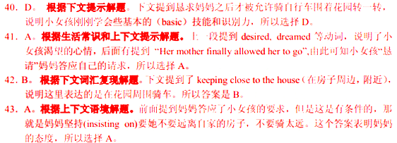
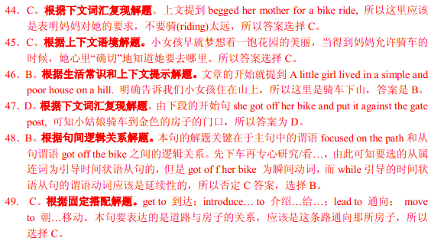
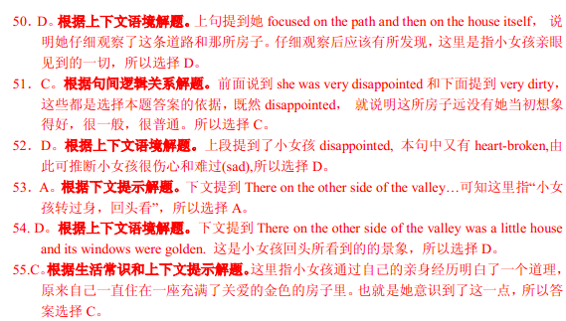

第三部分 阅读理解（共两节，满分40分）
- （共15小题；每小题2分，满分30分）
阅读下列短文，从每题所给的四个选项（A、B、C、D）中，选出最佳选项，并在答题卡上将该项涂黑。
A
China is a land of bicycles. At least it was back in 1992 when I traveled the country. Back then everyone seemed to be riding a bicycle. Millions of them, all black. Cars were rare. Yet since my arrival in Beijing last year, I’ve found the opposite is true. There are millions of cars. However, people still use their bicycles to get around. For many, it’s the easiest and cheapest way to travel today. Bicycles also come in different colors---sivler, green, red, blue, yellow, whatever you want.
It’s fun watching people biking. They rush quickly through crossroads, move skillfully through traffic, and ride even on sidewalks(人行道). Bicycles allow people the freedom to move about that cars just can’t provide.
Eager to be part of this aspect of Chinese culture, I decided to buy a bicycle. Great weather accompanied my great buy. I immediately jumped up on my bicycle seat and started home.
My first ride home was orderly (守秩序的). To be safe, I stayed with a “pack” of bikers while cars on the streets came running swiftly out of nowhere at times. I didn’t want to get hit. So I took the ride carefully.
Crossing the streets was the biggest problem. It was a lot like crossing a major highway back in the United States. The streets here were wide, so crossing took time, skill and a little bit of luck.
I finally made it home. The feeling on the bicycle was amazing. The air hitting my face and going through my hair was wonderful. I was sitting on top of the world as I passed by places and people. Biking made me feel alive.
56. According to the author, why are bicycles still popular in China today?
A. Because they are traditional and safe. B. Because they are convenient and inexpensive.
C. Because they are colorful and available. D. Because they are fast and environment friendly.
57. The author decided to buy a bicycle because he intended ______________.
A. to ride it for fun B. to use it for transport
C. to experience local skills D. to improve his riding skills
58. How did the author feel about his street crossing?
A. It was boring. B. It was difficult. C. It was lively. D. It was wonderful.
59. Which of the following best describes the author’s biking experience?
A. The author enjoyed showing off his biking skills.
B. The author was annoyed by the air while riding.
C. The author was praised by the other bikers.
D. The author took great pleasure in biking.
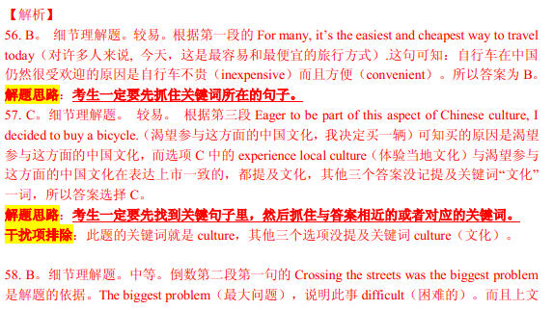
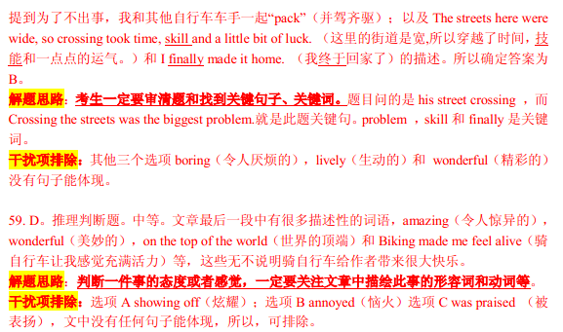
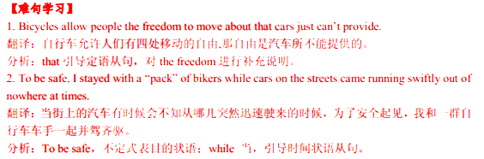
B
Going green seems to be fad(时尚)for a lot of people these days. Whether that is good or bad, we can’t really say, but for the tow of us, going green is not a fad but a lifestyle.
On April22, 2011, we decided to go green every single day for an entire year. This meant doing 365 different green things, and it also meant challenging ourselves to go green beyond easy things. Rather than recycle and reduce our energy, we had to think of 365 different green things to do and this was no easy task.
With the idea of going green every single day for a year, Our Green Year started. My life and I decided to educate people about how they could go green in their lives and hoped we could show people all the green things that could be done to help the environment. We wanted to push the message that every little bit helps.
Over the course of Our Green Year, we completely changed our lifestyle. We now shop at organic(有机的)stores. We consume less meat, choosing green food. We have greatly reduced our buying we don’t need. We have given away half of what we owned through websites. Our home is kept clean by vinegar and lemon juice, with no chemical cleaners. We make our own butter, enjoying the smell of home-made fresh bread. In our home office anyone caught doing something ungreen might be punished.
Our minds have been changed by Our Green Year. We are grateful for the chance to have been able to go green and educate others. We believe that we do have the power to change things and help our planet.
60. What might be the best title for the passage?
A. Going Green. B. Protecting the Planet.
C. Keeping Open-Minded D. Celebrating Our Green Year.
61. It was difficult for the couple to live a green life for the whole year because_________.
A. they were expected to follow the green fad
B. they didn’t know how to educate other people
C. they were unwilling to reduce their energy
D. they needed to perform unusual green tasks
62. What did the couple do over the course of Our Green Year?
A. They tried to get out of their ungreen habits.
B. They ignore others’ ungreen behavior.
C. They chose better chemical cleaners.
D. They sold their home-made food.
63. What can we infer form the last paragraph?
A. The government will give support to the green people.
B. The couple may continue their project in the future.
C. Some people disagree with the couple’s green ideas.
D. Our Green Year is becoming a national campaign.


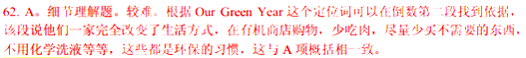


C
Here is an astonishing and significant fact: Mental work alone can’t make us tire. It sounds absurd. But a years ago, scientists tried to find out how long the human brain could labor without reaching a stage of fatigue (疲劳). To the amazement of these scientists, they discovered that blood passing through the brain, when it is active, shows no fatigue at all! If we took a drop of blood from a day laborer, we would find it full of fatigue toxins(毒素) and fatigue products. But if we took blood from the brain of an Albert Einstein, it would show no fatigue toxins at the end of the day.
So far as the brain is concerned, it can work as well and swiftly at the end of eight or even twelve hours of effort as at the beginning. The brain is totally tireless. So what makes us tired?
Some scientists declare that most of our fatigue comes from our mental and emotional(情绪的) attitudes. One of England’s most outstanding scientists, J.A. Hadfield, says, “The greater part of the fatigue from which we suffer is of mental origin. In fact, fatigue of purely physical origin is rare.” Dr. Brill, a famous American scientist, goes even further. He declares, “One hundred percent of the fatigue of sitting worker in good health is due to emotional problems.”
What kinds of emotions make sitting workers tired? Joy? Satisfaction? No! A feeling of being bored, anger, anxiety, tenseness, worry, a feeling of not being appreciated---those are the emotions that tire sitting workers. Hard work by itself seldom causes fatigue. We get tired because our emotions produce nervousness in the body.
64. What surprised the scientists a few years ago?
A. Fatigue toxins could hardly be found in a laborer’s blood.
B. Albert Einstein didn’t feel worn after a day’s work.
C. The brain could work for many hours without fatigue.
D. A mental worker’s blood was filled with fatigue toxins.
65. According to the author, which of the following can make sitting workers tired?
A. Challenging mental work. B. Unpleasant emotions.
C. Endless tasks. D. Physical labor.
66. What’s the author’s attitude towards the scientists’ idea?
A. He agrees with them. B. He doubts them.
C. He argues against them. D. He hesitates to accept them.
67. We can infer from the passage that in order to stay energetic, sitting workers need to ___________.
A. have some good food. B. enjoy their work
C. exercise regularly D. discover fatigue toxins

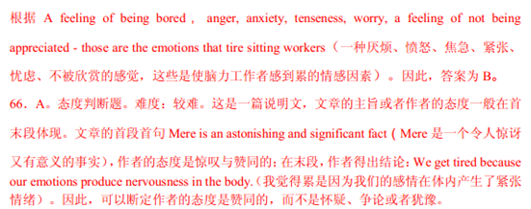

D
“Indeed,” George Washington wrote in his diary in 1785, “some kind of fly, or bug, had begun to eat the leaves before I left home.” But the father of America was not the father of bug. When Washington wrote that, Englishmen hade been referring to insects as bugs for more than a century, and Americans had already created lightning-bug(萤火虫). But the English were soon to stop using the bugs in their language, leaving it to the Americans to call a bug a bug in the nineteenth and twentieth centuries.
The American bug could also be a person, referring to someone who was crazy about a particular activity. Although fan became the usual term, sports fans used to be called racing bugs, baseball bugs, and the like.
Or the bug could be a small machine or object, for example, a bug-shaped car. The bug could also be a burglar alarm, from which comes the expression to bug, that is, “to install (安装) an alarm”. Now it means a small piece of equipment that people use for listening secretly to others’ conversation. Since the 1840s, to bug has long meant “to cheat”, and since the 1940s it has been annoying.
We also know the bug as a flaw in a computer program or other design. That meaning dates back to the time of Thomas Edison. In 1878 he explained bugs as “little problems and difficulties” that required months of study and labor to overcome in developing a successful product. In 1889 it was recorded that Edison “had been up the two previous nights discovering ‘a bug’ in his invented record player.”
68. We learn from Paragraph 1 that __________________.
- Americans had difficulty in learning to use the word bug
- George Washington was the first person to call an insect a bug
- the word bug was still popularly used in English in the nineteenth century
- both Englishman and Americans used the word bug in the eighteenth century
69. What does the word “flaw” in the last paragraph probably mean?
A. Explanation. B. Finding. C. Origin. D. Fault.
70. The passage is mainly concerned with__________________.
A. the misunderstanding of the word bug B. the development of the word bug
C. the public views of the word bug D. the special characteristics of the word bug


第二节（共5小题；每小题2分，满分10分）
根据短文内容，从短文后的选项中选出能填入空白处的最佳选项，并在答题卡上将该项涂黑。选项中有两项为多余选项。
Forgiveness
To forgive is a virtue, but no one has ever said it is easy. When someone has deeply hurt you, it can be extremely difficult to let go of your hate. However, forgiveness is possible, and it can be surprisingly beneficial to your physical and mental health. People who forgive show less sadness, anger and stress and more hopefulness, according to a recent research.
________71_______ Try the following steps:
Calm yourself. ________72_______ You can take a couple of breaths and think of something that gives you pleasure: a beautiful scene in nature, or someone you love.
Don’t wait for an apology. Many times the person who hurt you does not intend to apologize. They may have wanted to hurt you or they just don’t see things the same way. ________73_______ Keep in mind that forgiveness does not necessarily mean becoming friends again with the person who upset you.
Take the control away from your offender(冒犯者). Rethinking about you hurt gives power to the person who causes you pain. Instead of focusing on your mounded feelings, learn to look for the love, beauty and kindness around you.
________74_______ If you understand your offender, you may realize that he or she was acting out of unawareness, fear, and even love. You may want to write a letter to yourself from your offender’s point of view.
Don’t forget to forgive yourself. ________75_______ But it can rob you of your self-confidence if you don’t do it.
- Why should you forgive?
- How should you start to forgive?
- Recognize the benefits of forgiveness.
- Try to see things from you offender’s angle.
- For some people, forgiving themselves is the biggest challenge.
- To make your anger die away, try a simple stress-management technique.
- If you wait for people to apologize, you could be waiting an awfully long time.
第二卷
注意：将答案写在答题卡上，写在本试卷上无效。
第四部分——写作（共两节，满分35分）
- 短文改错（共10小题；每小题1分，满分10分）
假定英主事课上老师要求同桌之间交换修改作文，请您修改你同桌写的以下作文。文中共有10处语文错误，每句中最多有两处。每处错误仅涉及一个单词的增加、删除或修改。
增加：在缺词处加一个漏字符号（），并在其下面写出该加的词。
删除：把多余的词用斜钱（\）划掉。
修改：在错的词下划一横线，并在该词下面写出修改后的词。
注意：
1. 每处错误及其修改均仅限一词；
2．只充许修改10处，多者（从第11处起）不计分。
Mr. Johnson is a hardworking teacher. Every day, he spends too much time with his work. With little sleep and hardly any break, so he works from morning till night. Hard work have made him very ill. “He has ruined his healthy. We are worried about him.” That is which other teachers say. Yesterday afternoon. I paid visit to Mr. Johnson. I was eager to see him, but outside her room I stopped. I had to calm myself down. Quietly I step into the room. I saw him lying in bed, looking at some of the picture we had taken together. I understood that he missed us just as many as we missed him.

- 书面表达（满分25分）
一个英文网站面向中学生征稿。请你写一篇英文稿件，介绍“中秋节”及这个节日里的主要活动。
写作要点：
- 它是中国传统节日之一；
- 家人团聚；
- 赏月、吃月饼、
- 还有旅游、访友等其他活动。

注意：
- 词数100左右；
- 可以适当增加细节，以使用文连贯；
- 开头语已您写好，不讲总词数。
参考词汇：
中秋节:the Mid-Autumn Festival 农历: lunar calendar
赏月: enjoy the full moon 月饼: moon cake

The Mid- Autumn Fetival
The Mid-Autumn Festival falls on the 15th of the eighth month of Our Chinese lunar calendar.
……


