C
Many people think that listening is a passive business. It is just the opposite. Listening well is an active exercise of our attention and hard work. It is because they do not realize this, or because they are not willing to do the work, that most people do not listen well.
Listening well also requires total concentration upon someone else. An essential part of listening well is the rule known as ‘bracketing’. Bracketing includes the temporary giving up or setting aside of your own prejudices and desires, to experience as far as possible someone else’s world from the inside, stepping into his or her shoes. Moreover, since listening well involves bracketing, it also involves a temporary acceptance of the other person. Sensing this acceptance, the speaker will seem quite willing to open up the inner part of his or her mind to the listener. True communication is under way and the energy required for listening well is so great that it can be accomplished only by the will to extend oneself for mutual growth.
Most of the time we lack this energy. Even though we may feel in our business dealings or social relationships that we are listening well, what we are usually doing is listening selectively. Often we have a prepared list in mind and wonder, as we listen, how we can achieve certain desired results to get the conversation over as quickly as possible or redirected in ways more satisfactory to us. Many of us are far
more interested in talking than in listening, or we simply refuse to listen to what we don’t want to hear.
It wasn’t until toward the end of my doctor career that I have found the knowledge that one is being truly listened to is frequently therapeutic(有疗效的) In about a quarter of the patients I saw, surprising improvement was shown during the first few months of psychotherapy(心理疗法), before any of the roots of problems had been uncovered or explained. There are several reasons for this phenomenon, but chief among them, I believe, was the patient’s sense that he or she was being truly listened to, often for the first time in years, and for some, perhaps for the first time ever.
66. The phrase “stepping into his or her shoes” in paragraph 2 probably means _______.
A. preparing a topic list first B. focusing on one’s own mind
C. directing the talk to the desired results D. experiencing the speaker’s inside world
67. What is mainly discussed in Paragraph 2 ?
A. How to listen well. B. What to listen to.
C. Benefits of listening. D. Problems in listening
68. According to the author , in communication people tend to ________.
A. listen actively B. listen purposefully
C. set aside their prejudices D. open up their inner mind
69. According to the author , the patients improved mainly because _______.
A. they were taken good care of. B. they knew they were truly listened to.
C. they had partners to talk to. D. they knew the roots of problems.
70. What type of writing the article likely to be ?
A. Science fiction B. A news report. C. A medical report. D. Popular science
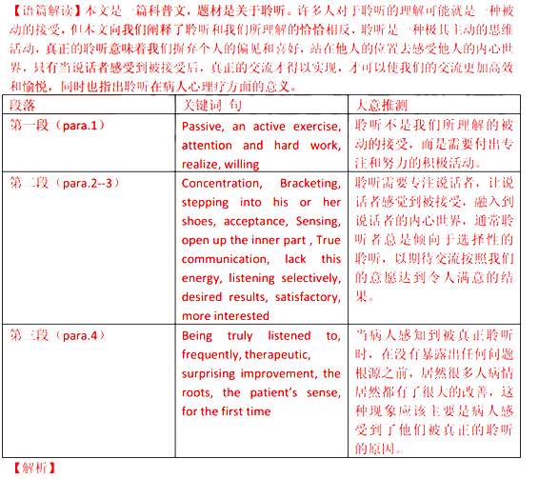
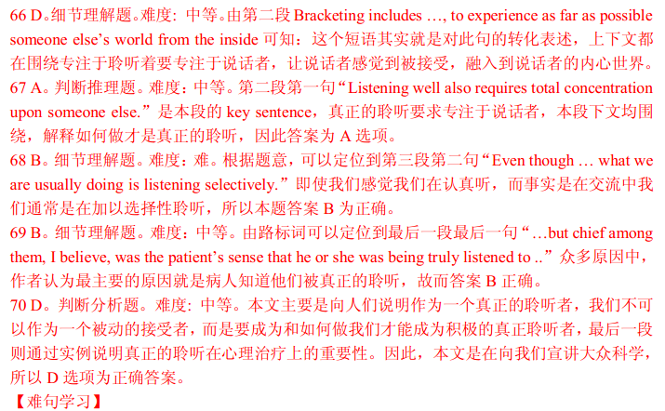
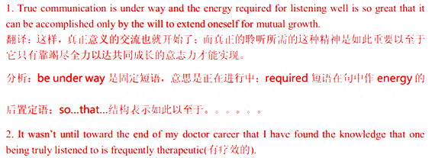
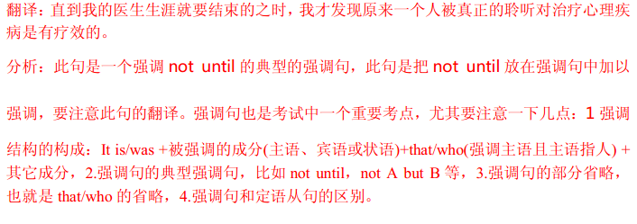
D
One might expect that the ever-growing demands of the tourist trade would bring nothing but. good for the countries that receive the holiday-makers. Indeed, a rosy picture is painted for the long-term future of the holiday industry. Every month sees the building of a new hotel somewhere, and every month another rock-bound Pacific island is advertised as the 'last paradise(天堂) on earth'.
However, the scale and speed of this growth seem set to destroy the very things tourists want to enjoy. In those countries where there was a rush to make quick money out of sea-side holidays, over-crowded beaches and the concrete jungles of endless hotels have begun to lose their appeal.
Those countries with little experience of tourism can suffer most. In recent years, Nepal set out to attract foreign visitors to fund developments in health and education. Its forests , full of wildlife and rare flowers, were offered to tourists as one more untouched paradise. In fact, the nature all too soon felt the effects of thousands of holiday-makers traveling through the forest land. Ancient tacks became major routes for the walkers, with the consequent exploitation of precious trees and plants.
Not only the environment of a country can suffer from the sudden growth of tourism. The people as well rapidly feel its effects. Farmland makes way for hotels, roads and airports; the old way of life goes. The one-time farmer is now the servant of some multi-national organization; he is no longer his own master. Once it was his back that bore the pain ; now it is his smile that is exploited. No doubt he wonders whether he wasn't happier in his village working his own land.
Thankfully, the tourist industry is waking up to the responsibilities it has towards those countries that receive its customers. The protection of wildlife and the creation of national parks go hand in hand with tourist development and in fact obtain financial support form tourist companies. At the same time, tourists are being encouraged to respect not only the countryside they visit but also its people.
The way tourism is handled in the next ten years will decide its fate and that of the countries we all want to visit. Their needs and problems are more important than those of the tourist companies. Increased understanding in planning world-wide tourism can preserve the market for these companies. If not, in a few years’ time the very things that attract tourists now may well have been destroyed.
71. What does the author indicate in the last sentence of Paragraph 1 ?
A. The Pacific island is a paradise. B. The Pacific island is worth visiting.
C. The advertisement is not convincing. D. The advertisement is not impressive
72. The example of Nepal is used to suggest _________ .
A. its natural resources are untouched. B. its forests are exploited for farmland
C. it develops well in health and education. D. it suffers from the heavy flow of tourists.
73. What can we learn about the farmers from Paragraph 4 ?
A. They are happy to work their own lands.
B. They have to please the tourists for a living.
C. They have to struggle for their independence.
D. They are proud of working in multi-national organizations.
74. Which of the following determines the future of tourism ?
A. The number of tourists B. The improvement of services.
C. The promotion of new products. D. The management of tourism
75. The author’s attitude towards the development of the tourist industry is __________.
A. optimistic B. doubtful C. objective D. negative

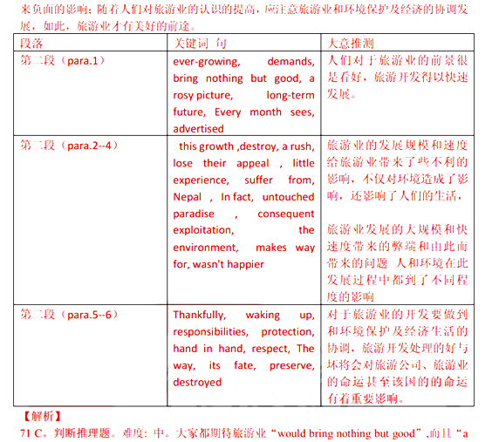
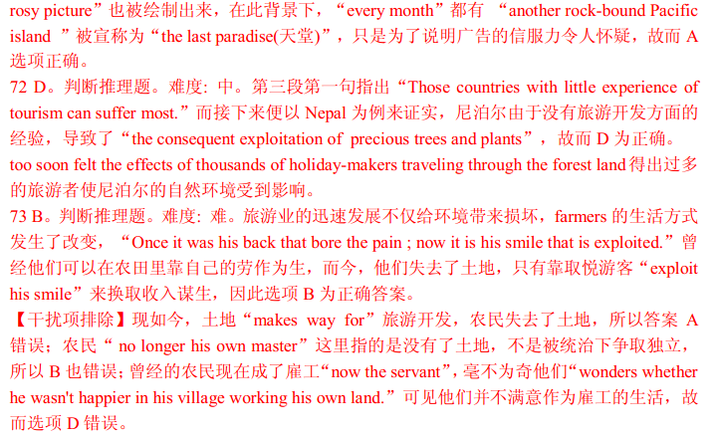
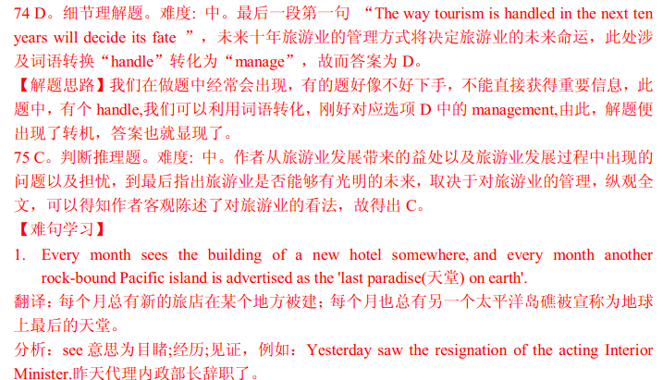
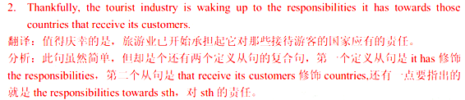
第二卷（非选择题 满分35分）
注意事项：
第二卷2页，须用黑色墨水签字笔在答题卡上书写作答。如在试题卷上作答，答案无效。

第四部分 写作（共两节，满分35分）
第一节 阅读表达（共5小题；每小题2分，满分10分）
阅读下面短文并回答问题，然后将答案写到答题卡相应的位置上（请注意问题后的词数要求）。
[1] Fishing is probably the world’s most popular sport. People spend many dollars each year on items like boats and four-wheel-drive vehicles. In addition, they spend money on fishing equipment , bait, fuel and boat repairs. And you can see that fishing can be an expensive pastime. Fishing lovers believe that their hobby is worth it. Others say that fishing is spoiling the environment and that it is a cruel hobby.
[2] Supporters of fishing say that it is a nice hobby. Firstly, of the millions of people who fish for fun, most only catch enough fish to feed their families. They catch fish that are found in large numbers, so there is little danger to the species (种类).
[3] Secondly, recreational fishermen contribute to the economy. They spend money on equipment and other items, and they also spend it indirectly by paying taxes on their equipment and fuel. Those who travel to fishing spots pay for accommodation (食宿) and airfares. This money keeps people in work and provides new jobs each year.
[4] Thirdly, fishing is relaxing and fun so it lessens stress. Instead of turning to drugs or alcohol, it is far better to go fishing. People who are relaxed are generally healthier and much nicer to be near ----- except for the smell of the bait !
[5] Those who _________________ say that there are too many fish thoughtlessly taken form rivers, lakes, streams and oceans. This could lead to the dying out of some species. Modern cars and boats mean that people can fish in remote areas of the world, so no place is safe from greedy fishermen who take both males and females, leaving few fish to produce young.
[6] Those against fishing also say that it is a blood sport, which means that an animal must die so that a human can have fun. Many of the fish caught for sport are not suitable for eating, so they are thrown away. Once hooked, fish have no chance of escape.
76. What is the main idea of the passage ? (no more than 4 words)
__________________________________________________________________________________
77. According to Paragraph 2 , why does fishing cause little danger to the species ?(no more than 8 words)
__________________________________________________________________________________
78. List 4 items on which people spend their money for fishing. (no more than 7 words)
__________________________________________________________________________________
79. Fill in the blank in Paragraph 5 with proper words.
Those who ______________________________ say that there are too many fish thoughtlessly taken form rivers, lakes, streams and oceans.
80. What does the word “which” (Line 1, Paragraph6) probably refer to ? (no more than 3 words)
__________________________________________________________________________________
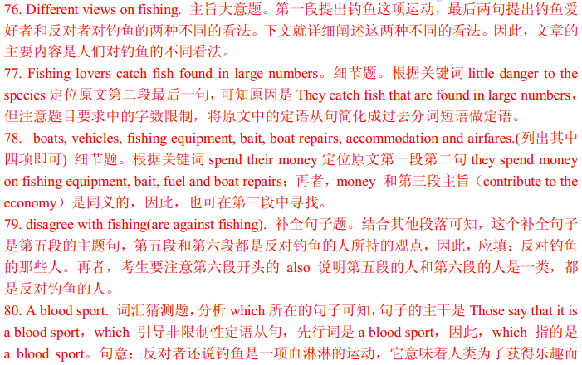
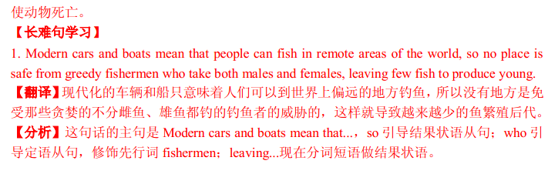
第二节 书面表达（满分25分）
星光中学（Xingguang High School）近期举行了一次登山活动。假定你是学校英语报记者，请写一篇短文，报道此次活动。内容包括：
1. 时间与地点：4月10日，大青山（Daqing Mountain）；
2. 活动的过程；
3. 你对于这次活动的评论。
注意： 1. 词数120左右。
2. 可适当增加细节，以使行文连贯。
