2013年普通高等学校招生全国统一考试（江西卷）
英 语
第Ⅰ卷（选择题 共115分）

第一部分 听力 （共两节，满分30分）
回答听力部分时，请先将答案标在试卷上。听力部分结束前，你将有两分钟的时间将您的答案转涂到客观答题卡上。
第一节（共5小题：每小题1.5分，满分7.5分）
听下面5段对话，每段对话后有一个小题，从题中所给的A、B、C三个选项选出最佳选项，并标在试卷的相应位置，听完每段对话后，你都有10秒钟的时间来回答有关小题和阅读下小题，每段对话仅读一遍。
例：How much is the shirt?
A. ￡19.15. B. ￡ 9.18 C.￡9.15.
答案是C。
1. What does the man want to do?
A. Take photos. B. Buy a camera C. Help the woman
2. What are the speakers talking about?
A. A noisy night B. Their life in town C. A place of living
3. Where is the man now ?
A. On his way B. In a restaurant C. At home
4. What will Celia do ?
A. Find a player B. Watch a game C. Play basketball
5. What day is it when the conversation takes place ?
A. Saturday B. Sunday C. Monday
第二节（共15小题：每小题1.5分，满分22.5分）
听下面5段对话。每段对话有几个小题，从题中所给的A、B、C三个选项中选出的最佳选项，并标在试卷的相应位置。听每段对 话前，你将有时间阅读各个小题，每小题5秒钟；听完后，各小题给出5秒钟的做答时间。每段对话读两遍。
听第6段材料，回答第6、7题。
6. What is Sara going to do ?
A. Buy John a gift. B. Give John a surprise C. Invite John to France
7. What does the man think of Sara’s plan ?
A. Funny B. Exciting C. Strange.
听第7段材料，回答第8、9题。
8. Why does Diana say sorry to Peter ?
A. She has to give up her travel plan.
B. She wants to visit another city.
C. She needs to put off her test.
9. What does Diana want Peter to do ?
A. Help her with her study B. Take a book to her friend C. Teach a geography lesson.
听第8段材料，回答第10至12题。
10. Why does the man call the woman ?
A. To tell her about her new job B. To ask about her job program C. To plan a meeting with her.
11. Who needs a new flat ?
A. Alex B. Andrea. C. Miranda.
12. Where is the woman now ?
A. In Baltimore. B. In New York. C. In Avon
听第9段材料，回答第13至16题。
13. What does Jan consider most important when he judges a restaurant ?
A. Where the restaurant is.
B. Whether the prices are low
C. How well the food is prepared.
14. When did Jan begin to write for a magazine ?
A. After he came back to Sweden
B. Before he went to the United States.
C. As soon as he got his first job in 1982.
15. What Jan do to find a good restaurant ?
A. Talk to people in the street. B. Speak to taxi drivers C. Ask hotel clerks.
16. What do we know about Jan ?
A. He cooks for a restaurant. B. He travels a lot for his work. C. He prefers American food.
听第10段材料，回答每17至20题。
17. What do we know about the Plaza Leon?
A. It’s a new building B. It’s a small town. C. It’s a public place.
18. When do parents and children like going to the Plaza Leon?
A. Saturday nights. B. Sunday afternoons. C. Fridays and Saturdays.
19. Which street is known for its food shops and markets ?
A. Via del Mar Street. B. Fernando Street C. Hernandes Street.
20. Why does the speaker like Horatio Street best ?
A. It has an old stone surface. B. It is named after a writer. C. It has a famous university.
第二部分英语知识运用（共两节.满分45分）
笫一节单项填空（共15小题，每小题1分，共15分）
从A、B、C、D四个选项中.选出可以填入空白的最佳选项，并在答题卡上将该项涂黑。
21. ---- Thanks a lot for your book. I found it very interesting.
---- _______. I’m glad you enjoyed it.
A. All the best B. It is nothing C. No thanks D. Very well.
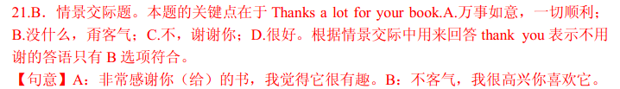
22. Whenever I made mistakes, the teacher pointed them out with ______.
A. curiosity B. satisfaction. C. envy D. patience.
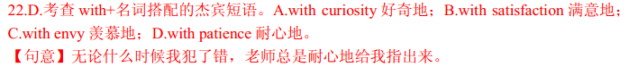
23. _______ can be good at something for 40 years if he doesn’t love it.
A. Anybody B. Everybody C. Nobody D. Somebody
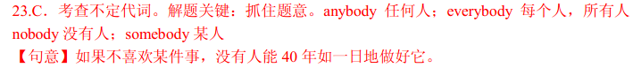
24. What a terrible experience ! ________, you’re safe now ------ that’s the main thing.
A. Anyway. B. Besides. C. Otherwise. D. Therefore.
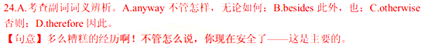
25. Only when he apologizes for his rudeness ____to him again.
A. I will speak. B. will I speak. C. do I speak. D. I speak.
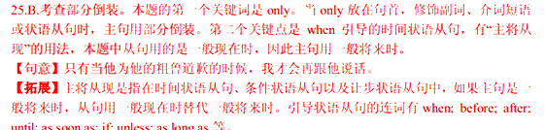
26. There are a small number of people involved, possibly ______twenty.
A. as few as B. as little as C. as many as D. as much as
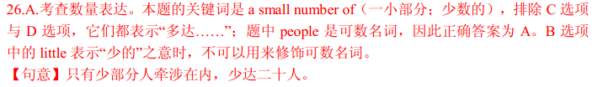
27. Mother always complains that children _______ their shoes very quickly.
A. find out B. wash out C. wear out D. set out
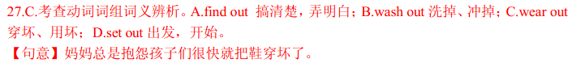
28. She says that she’ll have to close the shop ________ business improves.
A. if B. unless C. after D. when
29. When I was a child, I ______ watch TV whenever I wanted to.
A. should B. could C. must D. need
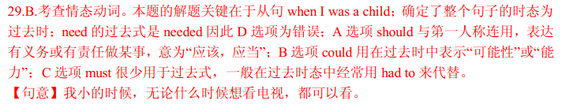
30. _______ one of you breaks the window will have to pay for it.
A. Whoever B. Whatever C. Whichever D. Wherever.
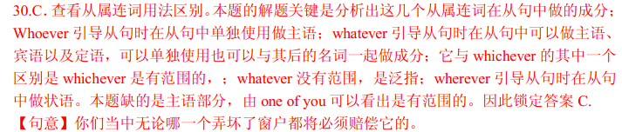
31. She _____ the carpet with some very nice curtains in colour.
A. connected B. fitted C. equipped D. matched.
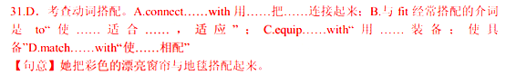
32. Animals are obviously ______ lower form of life than _______ man.
A. a ; / B. the ; the C. a ; the D. / ; /
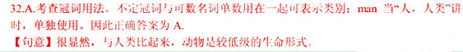
33. He wrote a letter ______ he explains what had happened in the accident.
A. what B. which C. where D. how
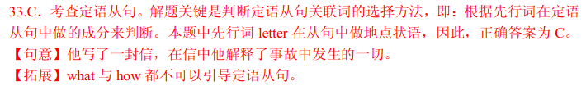
34. If _____ to look after luggage for someone else, inform the police at once.
A. asked B. to ask C. asking D. having asked
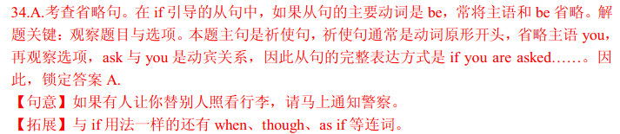
35. I ________ to visit you later that day, but I had to phone and cancel.
A. come B. came C. am coming D. was coming
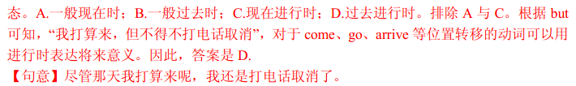

第二节完形填空(共20小题，每小题1.5分，满分30分)
阅读下面短文，掌握其段落大意，然后从36至55各题所给的四个选项A.B.C和D，选出最佳选项，并在答题卡上将该项涂黑。
Diane Ray was completely self-centered and very spoilt. Her parents gave her 36 she wanted, knowing that she would throw a temper tantrum(耍小孩脾气)if they did not. She would scream and kick and 37 on the floor drumming her heels. Her parents always 38 .
That was why she was alone on the 39 , wearing an expensive swimsuit. It has taken a massive tantrum to 40 her parents to buy it. They were back at the beach-house, 41 from the tantrum she had thrown when they told her that it was too dangerous to go diving 42 . “Dangerous ?” she had said. “You just don’t want me to have 43 . I’m going and if you try to stop me, I’ll scream.”
“What are you doing ?” a voice asked. Diane jumped. She did not know that the man was there 44 he spoke .
“I’m going diving, ” she answered.
“You shouldn’t swim that day, ” the man 45 . “There is a storm coming up.”
“You should mind your own 46 !” Diane replied and walked into the gentle waves.
“If you go out there you’ll be 47 ,” the man called after her. She did not bother to reply.
Diane slipped into the water and dived 48 until white caps began rolling in and it became harder to 49 against the current (水流). Saltwater hit against her face, making it 50 to breathe. Oh, why had she not listened to advice.
Panicking, she began to 51 . Then, just as it seemed as if she would slip beneath the surface, she heard a 52 voice. “Hold on ! I’m coming.” With 53 , she say the old man rowing an ancient-looking boat towards her. “I hope you’ve learned a lesson. You put us both in 54 , ” he shouted angrily, as he dragged her over the side of the 55 . Gratefully, Diane thanked him and ran towards the beach-house.
36. A. either B. neither C. nothing D. everything
37. A. jump B. lie C. spin D. sleep
38. A. set out B. set in C. gave in D. gave out
39. A. beach B. bed C. floor D. ship
40. A. allow B. warn C. get D. prefer
41. A. changing B. recovering C. appearing D. traveling
42. A. alone B. away C. again D. aside
43. A. time B. money C. food D. fun
44. A. when B. until C. after D. once
45. A. decided B. intended C. advised D. repeated
46. A. business B. swimsuit C. friends D. parents
47. A. angry B. sorry C. confused D. excited
48. A. nervously B. sadly C. shyly D. happily
49. A. rise B. swim C. stop D. row
50. A. difficult B. easy C. comfortable D. suitable
51. A. speak B. sing C. sniff D. scream
52. A. calm B. frightening C. beautiful D. disgusting
53. A. regret B. relief C. interest D. ease
54. A. power B. safety C.. danger D. thought
55. A. house B. wave C. beach D. boat
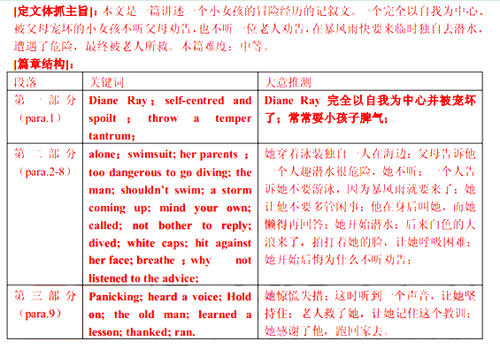
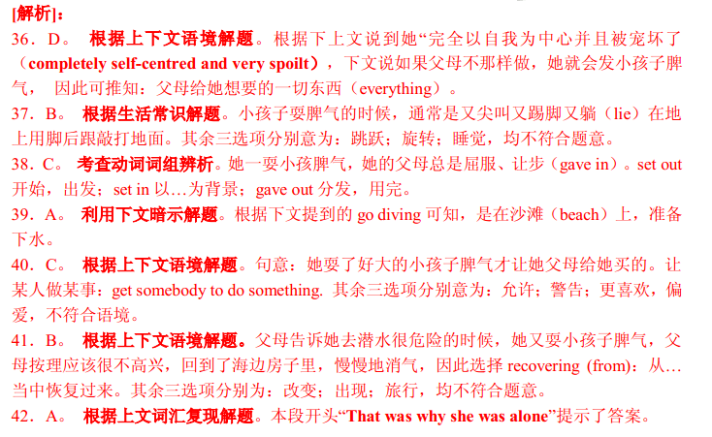
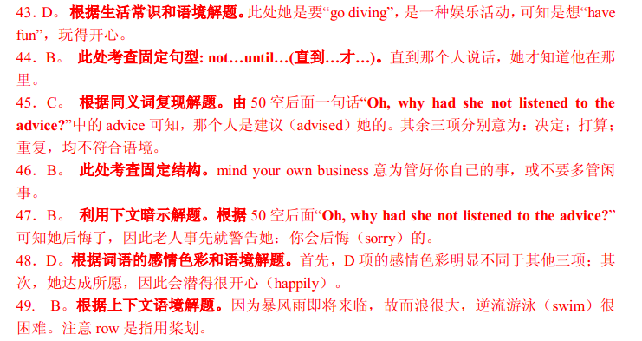
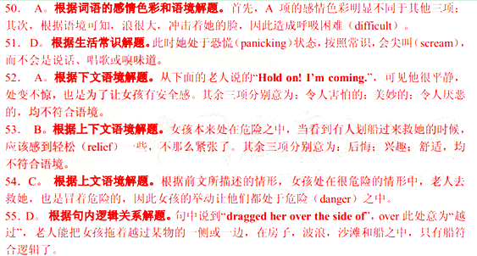
第三部分 阅读理解（共20小题；每小题2份，满分40分）
阅读下列短文，从每题所给的四个选项（A、B、C和D）中，选出最佳选项，并在答题卡上将该项涂黑。
A
The light from the campfire brightened the darkness, but it could not prevent the damp cold of Dennis’s Swamp (沼泽地) creeping into their bones. It was a strange place. Martin and Tom wished that they had not accepted Jack’s dare. They liked camping, but not near this swamp.
“So,” Martin asked as they sat watching the hot coals. “How did this place get its name ? ”
“Are you sure you want to hear it ? It’s a scary story,” warned Jack.
“Of course!” cried out Tom. “If there were anything to be scared of, you wouldn’t have chosen this place!”
“Ok, but don’t say I didn’t warn you,” said Jack, and he began this tale.
“Way back in time, a man called Dennis tried to start a farm here. He built that cottage over there to live in . In those days, the area looked quite different ---- it was covered with tall trees and the swamp was a crystal-clear river. After three hard years, Dennis had cleared several fields and planted crops. He was so proud of his success that he refused to listen to advice.
“ ‘You are clearing too much land, ’ warned one old man. ‘ The land is a living thing. It will hit back at you if you abuse it. ’
“ ‘ Silly fool,’ said Dennis to himself. ‘If I clear more land, I can grow more crops. I’ll become wealthier. He’s just jealous!’”
“Dennis continued to chop down trees. Small animals that relied on them for food and shelter were destroyed. He was so eager to expand his farm that he did not notice the river flowing slowly towards his door. He did not notice salt seeping to the surface of the land. He did not notice swamp plants choking all the native plants.”
“What happened ? ” Martin asked. It was growing colder. He trembled, twisting his body closer to the fire.
“The land hit back ---- just as the old man warned, ” Jack shrugged. “Dennis disappeared. Old folks around here believe that swamp plants moved up from the river and dragged him underwater. His body was never found.”
“What a stupid story, ” laughed Tom. “Plants can’t …” Before he had finished speaking, he screamed and fainted(晕倒). The other two boys jumped up with fright, staring at Tom. Suddenly, they burst out laughing. Some green swamp ivy (常春藤) had covered Tom’s face. It was a while before Tom could appreciate the joke.
56. The underlined word “dare” in Paragraph 1 is closed in meaning to ________.
A. courage B. assistance C. instruction D. challenge
57. Why did Jack tell Tom and Martin the story ?
A. To frighten them.
B. To satisfy their curiosity.
C. To warn them of the danger of the place.
D. To persuade them to camp in the swamp.
58. Why did Dennis ignore the warning of the old man ?
A. The old man envied him. B. The old man was foolish
C. He was too busy to listen to others. D. He was greedy for more crops.
59. Why did Tom scream and faint ?
A. He saw Dennis’s shadow B. He was scared by a plant
C. His friends played a joke on him. D. The weather became extremely cold.
60. What lesson can we learn from the story of Dennis ?
A. Grasp all, lose all. B. No sweat, no sweet.
C. It is no use crying over spilt milk. D. He who makes no mistakes makes nothing.
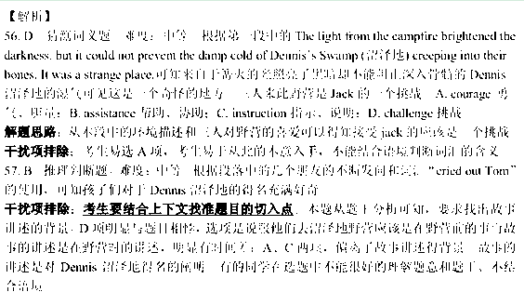
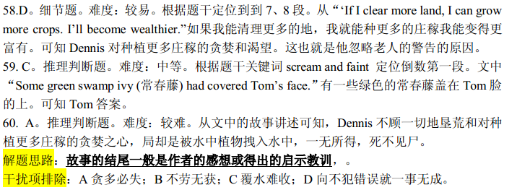
B
When international aid is given, steps must be taken to ensure (确保)that the aid reaches the people for whom it is intended. The way to achieve this may not be simple. It is very difficult for a nation to give help directly to people in another nation. The United Nations Organiztion(UNO) could undertake to direct the distribution of aid. Here however rises the problem of costs. Also tied with this is time. Perhaps the UNO could set up a body of devoted men and women is every country who can speedily distribute aid to victims of floods and earthquakes.
More than the help that one nation can give to another during a disaster, it would be more effective to give other forms of help during normal times. A common proverb says, “Give me a fish and I eat for day, teach me to fish and I eat for a lifetime.” If we follow this wise saying, it would be right to teach people from less developed nations to take care of themselves. For example, a country could share its technology with another. This could be in simple areas like agriculture or in more complex areas like medical and health care or even in building satellites. Even small country is able to help less developed nations. Sometimes what is take for granted, like the setting up of a water purification plant or the administration of a school, could be useful for countries which are looking about to solve common problems. It does not cost much to share such simple things. Exchange students could be attached for a number of months or years and learn the required craft while on the site. They can then take their knowledge back to their homelands and if necessary come back form time to time to clear doubts or to update themselves. Such aid will be truly helpful and there is no chance of it being temporary or of it falling into the wrong hands.
Many countries run extensive courses in all sorts of skills. It will not cost much to include deserving foreigners in these courses. Besides giving effective help to the countries concerned, there is also the build-up of friendships to consider. Giving direct help by giving materials may be effective in the short run and must continue to be given in the event of emergencies. However, in the long run what is really effective would be the sharing of knowledge.
61. According to the author, how could international aid reach the victims in time ?
A. By solving the cost problems
B. By solving the transportation problems
C. By setting up a body of devoted people in every country.
D. By relying on the direct distribution of the UNO.
62. What does the author try to express in the underlined sentence ?
A. Providing food is vital B. Learning to fish is helpful
C. Teaching skills is essential D. Looking after others is important.
63. The second paragraph is developed mainly _________.
A. by example B. by process C. by comparison D. by contrast
64. Which aid is likely to fall into the wrong hands ?
A. A medical team. B. An exchange program.
C. A water plant. D. Financial support.
65. What can we infer about international aid from the passage ?
A. It is facing difficulties. B. It is unnecessary during normal times
C. It should be given in the form of materials D. It has gained support developed countries


