上海市崇明县2015届高三上学期期末考试（一模）
英语试题
（考试时间120分钟，满分150分。请将答案填写在答题纸上）
第Ⅰ卷 (共103分)
I. Listening Comprehension
Section A
Directions In Section A, you will hear ten short conversations between two speakers. At the end of each conversation, a question will be asked about what was said. The conversations and the questions will be spoken only once. After you hear a conversation and the question about it, read the four possible answers on your paper, and decide which one is the best answer to the question you have heard.
1. A. Wednesday. B. Friday. C. Sunday. D. Tuesday.
2. A. By subway. B. By taxi. C. In Richard’s car. D. On Jerry’s train.
3. A. Boss and secretary. B. Guest and hotel staff.
C. Tourist and tour guide. D. Customer and shop assistant.
4. A. In a clinic. B. In a supermarket.
C. In a restaurant. D. In a ice-cream shop.
5. A. She doesn’t like going outside. B. The man should study now.
C. She doesn’t want to study now. D. The man should take some exercise.
6. A. A journalist. B. An artist. C. A teacher. D. An economist.
7. A. He may dislike travelling. B. He may like to travel in other seasons.
C. He may be unable to afford the trip. D. He may prefer to travel to other places.
8. A. The way of spending time wisely. B. The trouble of keeping clocks going.
C. The number of clocks the man has. D. The reason for the man’s having many clocks.
9. A. The Edwards are quite well-off.
B. It’ll be unwise for the Edwards to buy another house.
C. The Edwards should cut down on their living expenses.
D. It’s too expensive for the Edwards to live in their present house.
10. A. The man was seriously injured in the car accident.
B. The man had poor imagination because of the car accident.
C. The man wasn’t wearing the seat belt when the accident happened.
D. The man’s daughter advised him to wear the seat belt before he left home.

Section B
Directions In Section B, you will hear two short passages, and you will be asked three questions on each of the passages. The passages will be read twice, but the questions will be spoken only once. When you hear a question, read the four possible answers on your paper and decide which one would be the best answer to the question you have heard.
Questions 11 through 13 are based on the following passage.
11. A. The benefits of walking. B. The importance of keeping fit.
C. The way of forming a habit. D. The possibility of excising regularly.
12. A. Walking needs much thinking.
B. Walking improves people’s memory.
C. Walking is suitable for almost everyone.
D. Walking helps people concentrate on other things.
13. A. It is the easiest way to lose weight. B. It should be made part of people’s life.
C. It can make people’s heart stronger. D. It prevents people suffering from cancer.

Questions 14 through 16 are based on the following passage.
14. A. A way to get special rewards from project owners.
B. A formal project that can get funded on Kickstarter.
C. A special website helping creative projects find support.
D. A story about Mozart’s seeking supporters for his concerts.
15. A. 5,000,000. B. 60,000. C. 10,000. D. 200.
16. A. The projects should be finished by the creators.
B. Only well-known people can share their projects.
C. Supporters can contribute anything to the projects.
D. Creators must promise financial rewards for supporters.

Section C
Directions In Section C, you will hear two longer conversations. The conversations will be read twice. After you hear each conversation, you are required to fill in the numbered blanks with the information you have heard. Write your answers on your answer sheet.

Blanks 17 through 20 are based on the following conversation.
Complete the form. Write ONE WORD for each answer.
DANIEL’S MEMO
Jan. 9,2015
THING TO DO to pick up Lily’s brother at the airport
TIME 2 p.m. tomorrow
HIS APPEARANCE shortish with dark brown hair and a thick 17
HIS AGE in his 18
HIS CHARACTER easy-going, 19 but a little shy
PLACE TO GO the cinema 20 Lily’s office building

Blanks 21 through 24 are based on the following conversation.
Complete the form. Write NO MORE THAN THREE WORDS for each answer.
What will Ellen do first? | She will 21 first.
Why can’t John go with Ellen? | Because he has to 22 they read in class.
What does Ellen offer to do for John? | She offers to help John 23 .
Where will they meet later? | They will meet 24 .

II. Grammar and Vocabulary
Section A
Directions After reading the passages below, fill in the blanks to make the passages coherent and grammatically correct. For the blanks with a given word, fill in each blank with the proper form of the given word; for the other blanks, use one word that best fits each blank.
(A)
A woman was waiting at an airport one night. She hunted for a book, bought a bag of cookies and found a place to sit.
She was absorbed in her book but happened (25) ____(see) that the man sitting beside her grabbed a cookie or two from the bag in between them. She tried to ignore it. As the greedy cookie thief kept (26) ____ (eat) ,she munched(大声咀嚼) some cookies and watched the clock.
She was getting angrier as time went by, thinking, “If I weren’t so nice, I would blacken his eyes.” With each cookie she took, he took one, too; when only one was left, she wondered what he (27) _____ (do).
With a smile on his face, and nervous laugh, he took the last cookie and broke it (28) _____half. He offered her a half, and ate (29) _____ _____She grabbed it from him and thought, “Ooh, this guy is so rude! Why didn’t he even show any gratitude?”
When her flight was called, she gathered her belongings and headed for the gate, (30) ____(refuse) to look back at the rude thief. She boarded the plane, sank in her seat, and looked for her book.
As she reached in her baggage, she found her bag of cookie with surprise. “(31) _____ mine is here, the others were his, and he tried to share! How rude I was! It was I who (32) _____ have showed gratitude.”

(B)
Studying for an exam while listening to music is not smart, (33) _____ background music can reduce your ability to perform memory tasks, new research has found.
Study participants were asked to recall a list of eight letters in the order they (34) _____ (present). They did this while in five different sound environments quiet surroundings; music they liked; music they disliked; changing state (an order of random digits); and steady state (an order of steady digits such as “3,3,3,3”).
The participants’ recall ability was the poorest when listening to music, regardless of (35) _____ they liked or disliked it, and in changing-state conditions. (36) _____(accurate) recall occurred when participants performed the task in steady-state environments, according to the study (37) _____(publish) online in the journal Applied Cognitive Psychology.
“It is the sound variation in the music and changing state (38) _____ reduces the ability to recall the order of items within the presented list,” explained the leading researcher Nick Perham, (39) _____ is a lecturer in the School of Psychology at the University of Wales Institute in Cardiff, in a news release from the journal’s publisher.
When performing (40) _____ challenging mental task, do it in silence, Perham recommended.

Section B
Directions Complete the following passage by using the words in the box. Each word can only be used once. Note that there is one word more than you need.
A. embarrassing | B. claims | C. equipped | D. launched | E. accused
F. previously | G. properly | H. features | I. completely | J. unreliable | K. concerns

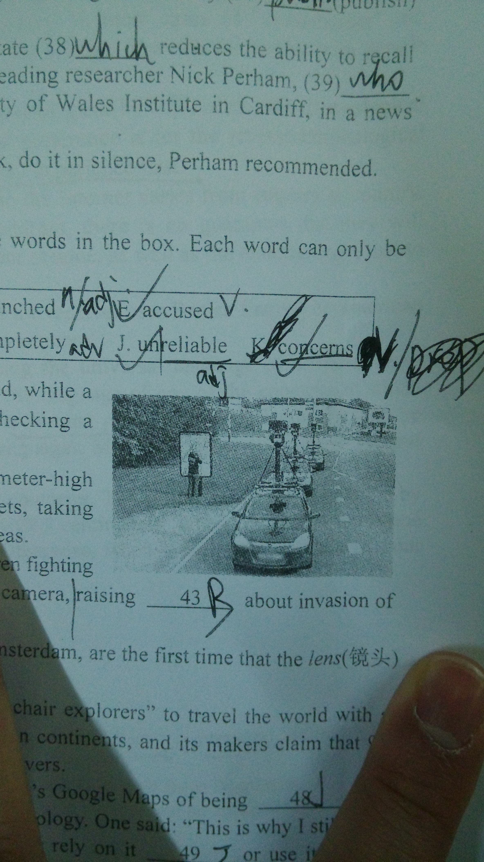
A row of cars appears to be stranded on a remote road, while a confused man on the left of the photo looks to be checking a roadside map while he calls for help.
The street view cars, each 41 with nine 2.5 meter-high multi-directional cameras, silently travel around the streets, taking pictures of city centers, side streets and even residential areas.
They have 42 captured sunbathing girls, children fighting and even a man dressed as Paddington Bear waving at the camera, raising 43 about invasion of privacy.
But these potentially 44 shots, taken near Amsterdam, are the first time that the lens(镜头) has been turned on the Google company and its black cars.
Google street View, 45 in 2007, allows “armchair explorers” to travel the world with a click of a mouse button. It 46 locations on all seven continents, and its makers claim that 95 percent of the UK has been mapped out on the company’s servers.
Some users of the service, who 47 the company’s Google Maps of being 48 , said that the picture showed that you couldn’t always rely on technology. One said “This is why I still have a map in my car. I often use Google Streetview, but I never rely on it 49 or use it to plan routes.” Another added “It told me to drive straight through a petrol station on one occasion.”
A Google spokesperson denied the 50 . She said “It doesn’t look to me like they’re lost. The drivers undergo training so they know how to use the equipment and it looks like this might more likely be what they’re doing.”

III. Reading Comprehension
Section A
Directions For each blank in the following passage there are four words or phrases marked A, B, C and D. Fill in each blank with the word or phrase that best fits the context.

Surprising new research suggests it can actually be good to feel bad at work, and that feeling good in the workplace can lead to negative outcomes.
The study of emotions in the workplace, edited by University of Liverpool researchers Drs. Dirk Lindebaum and Peter Jordan, is the 51 of a Special Issue of the journal Human Relations.
They found that the 52 held assumption that positivity in the workplace produces positive outcomes, while negative emotions lead to negative outcomes, may be in need for 53 . This is partly due to this assumption 54 to take into account the differences in work contexts which effect outcomes.
For instance, anger does not always lead to negative outcomes and can be used as a force for good through acting upon injustices. In some 55 , anger can be considered a force for good if motivated by perceived violations(违背) of moral standards. An employee, for example, could express anger constructively after a manager has treated a fellow worker 56 . In such cases, anger can be useful to 57 these acts of injustice from repeating themselves in the future.
Likewise, being too positive in the workplace, 58 resulting in greater well-being and greater productivity, can lead to self-satisfaction and superficiality(肤浅).
One article within the issue also finds that, within team situations, negativity can have a good effect, leading to less 59 and therefore greater discussion among workers which 60 team effectiveness.
An interesting contradiction(矛盾) is identified in another study of the special issue. Here, people gain 61 from doing “good” in the context of helplines by providing support to people in times of emotional distress. 62 , they are negatively affected by their line of work due to people trying to avoid them in social situations.
Lindebaum said, “The findings of the studies published in this Special Issue 63 the widely held assumption that in the workplace positive emotions 64 a positive outcome, and vice verse. This Special Issue adds to our knowledge and understanding of how the positive and negative emotions affect the 65 environment and has practical application and relevance in the workplace.”

51. A. application B. topic C. cause D. objective
52. A. basically B. logically C. commonly D. blindly
53. A. reconsideration B. recommendation C. recognition D. reassurance
54. A. stopping B. failing C. tending D. managing
55. A. aspects B. companies C. cultures D. cases
56. A. gently B. strangely C. irregularly D. unfairly
57. A. prevent B. keep C. find D. have
58. A. in spite of B. apart from C. instead of D. owing to
59. A. agreement B. thinking C. production D. initiative
60. A. determines B. enhances C. reduces D. influences
61. A. independence B. knowledge C. satisfaction D. strength
62. A. Moreover B. Therefore C. Otherwise D. However
63. A. support B. challenge C. include D. confirm
64. A. contribute to B. result from C. fit in with D. get over
65. A. social B. surviving C. natural D. working

Section B
Directions Read the following three passages. Each passage is followed by several questions or unfinished statements. For each of them there are four choices marked A, B, C and D. Choose the one that fits best according to the information given in the passage you have just read

(A)
The term “resume” means a document describing one’s educational qualitifications and professional experience. However guidelines for preparing a global resume are constantly changing. The best advice is to find out what is appropriate regarding the company culture, the country culture, and the culture of the person making the hiring decision. The following list is a good place to start.
* In many countries, it is standard procedure to attach a photo or have your photo printed on your resume. Do not attach a photograph to your resume if you are sending it to the United States, though.
* Educational requirements differ from country to country. In most case of “cross-border” job hunting, just stating the title of your degree will not be enough. Provide the reader with details about your studies and any related experience.
* Pay attention to the resume format(格式) you use--chronological(时间的) or revers-chronological order. If you find no specific guidelines, the general preference is for the revers-chronological format,which means listing your current or most recent experience first.
* The level of computer technology and accessibility to the Internet varies from country to country. Even if a company or individual lists an e-mail address, there is no guarantee that they will actually receive your email. Send a paper copy of your resume , as well as the emailed copy, just to make sure that it is received.
* If you are writing your resume in English, find out if the receiver uses British English or American English because there are variations between the two versions.
* Although English is widely accepted today as being the universal language of business, most multinational companies will expect you to speak the language of one of the countries in which they do business, in addition to English. Have your resume prepared in both languages, and be ready for your interview to be conducted in both languages. Most companies will want to see and hear proof of your language skills.
* Be aware that paper sizes are different countries. The United States standard is 81/2 by 11 inches, while the European A4 standard is 21 by 29.7 centimeters.When you send your resume by email, reformat it to the receiver’s standard. Otherwise, when it is printed out,half of your material may be missing.
66. The passage is most probably intended for ______ .
A. Job hunters that seek careers abroad
B. Companies that do international business
C. People that are employed by companies overseas
D. Graduates that can speak over one foreign language
67. Which of the following is always advisable when a global resume is prepared according to the passage ?
A. Write it in American English. B. Prepare it in at least three languages
C. Attach or print your photo on it. D. Send both a paper and emailed copy.
68. From the passage, we learn that ______.
A. We can’t list the oldest experience first in a resume
B. Asian countries may have the same standard paper size
C. A resume can help us know about a person’s personality
D. A person’s educational background should be included in a resume
69. The passage mainly wants to tell us that a global resume should ______.
A. Be highly professional B. Be especially informative
C. Be culturally appropriate D. Be logically chronological

(B)
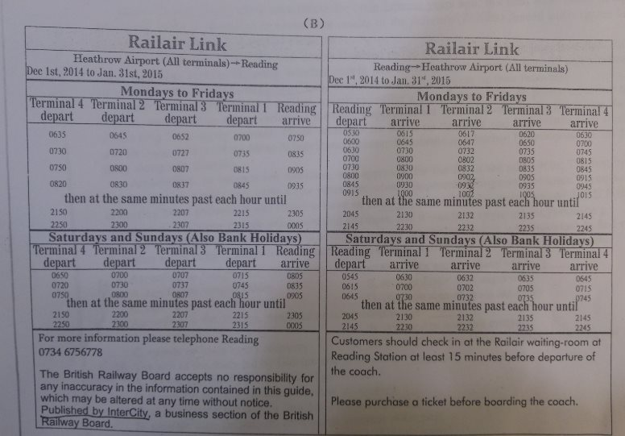

70. On December 25th, 2014, the first coach from Heathrow Terminal 1 to Reading departs ______.
A. 715. B. 700. C. 650. D. 635.
71. If you are to reach Terminal 2 of the Heathrow Airport before 1000 a.m., you need to get to Reading Station not later than ______.
A. 820 a.m. B. 845 a.m. C. 900a.m. D. 915a.m.
72. The information leaflet is produced by ______.
A. Reading B. InterCity C. Railair Link D. Heathrow Airport
73. According to the timetable, all passengers should ______.
A. Buy return tickets B. Buy their tickets on the bus
C. Buy the tickets online D. Buy their tickets in advance

(C)
Researchers are reporting the first treatment to speed recovery from severe brain injuries caused by falls and car crashes a cheap flu medicine--amantadine, whose side benefits were discovered by accident decades ago.
Severely injured patients in the United States, Denmark and Germany who were given amantadine got better faster than those who received another medicine. After four weeks, more people in the flu drug group could give reliable yes-and-no answers, follow commands or use a spoon or hairbrush--things that none of them could do at the start. Far fewer patients who got amantadine remained in a vegetative state, 17 percent versus 32 percent.
“This drug moved the needle in terms of speeding patient recovery, and that’s not been shown before,” said neuropsychologist(神经心理学家) Joseph Giacino of Boston’s Spaulding Rehabilitation Hospital, co-leader of study. He added“It really does provide hope for a population that is viewed in many places as hopeless.”
Many doctors began using amantadine for brain injures years ago, but until now there’s never been a big study to show that it works. The results of the federally(联邦地) funded study appear in Thursday’s New England Journal of Medicine.
A neuropsychologist(神经心理学家) who wasn’t involved in the research called it an important step. But many questions remain, including whether people less severely injured would benefit, and whether amantadine actually improves patients’ long-term outcome or just speeds up their recovery.
Each year, an estimated 1.7 million American suffer a brain injury. With no proven treatment to rely on, doctors have used a variety of medicines approved for other disease in the hopes that they would help brain injury patients. Those decisions are based on “guesses and logic rather than data” said Dr. John Whyte, of the Moss Rehabilitation Research Institute in suburban Philadelphia. He led the study along with Giacino.
Amantadine, an inexpensive medicine, was approved for the flu in the mid-1960s. The first hint that it might have other uses came a few years later when it appeared to improve Parkinson’s symptoms in nursing home patients. It was found to have an effect on the brain’s doparmine system(多巴胺系统), whose function include movement and alertness, and it was later approved for Parkinson’s.
It’s now commonly used for brain injuries, and the researchers felt it was important to find out “whether we’re treating patients with a useful drug, a harmful drug or a useless drug,” Whyte said.

74. According to Paragraph 1, the patients in a vegetative state may be those who ______.
A. Can follow simple orders B. Recover faster than expected
C. Can’t breathe on their own D. Show no sign of brain activities
75. According to the passage, Amantadine is a medicine that ______.
A. Is useful for flu only B. Is aimed to improve memory
C. Speeds up brain injury recovery D. Benefits patients’ brain injuries in the long run
76. The aim of the study led by Giacino and Whyte is to ______.
A. Get enough fund from the federal government
B. Prove the effect of Amantadine on brain injuries
C. Publish its results in New England Journal of Medicine
D. Provide hope for patients considered hopeless in the past
77. Which of the following might be the best title of the passage ?
A. Old Drug,Proven Side Benefit B. Medical Study, New Discovery
C. Severe Brain Injury, Quick Recovery D. Different Treatment, Obvious Effect

Section C
Directions Read the passage carefully. Then answer the questions or complete the statements in the fewest possible words.
Defenders of the French language are angered by plans to introduce courses taught in English at public universities, arguing that France must protect itself against the risk of losing its cultural identity.
The French Parliament recently started to debate the issue as part of a bill on a broader reform of higher education, but all attention has focused on an article that would lift a 19-year ban on English as a teaching language at public universities.
The French government backs the change, which it says would help to attract foreign students and help French graduates compete in a global economy as the country struggles to regain competitiveness. More French students fearing poor job prospects at home, where youth unemployment is nearly 25 percent, are studying and working abroad. One of their destinations is London, which now has become the sixth largest French population in the world.
However, opponents of the law, including professors, lawmakers and the French language supervision body Academic France, say the community of other French-speaking peoples must be defended and that the change would be a betrayal of other French-speaking nations."If France gives other French-speaking countries the wrong signal by leading an assault against the language, that would be a very, very regrettable thing indeed," said Claude Hagege, a language scientist.
France has long defended its culture at home and abroad. In 1994, the so-called " Toubon Law" made the use of French mandatory in all TV broadcasts, meaning all foreign-language programs are dubbed, while radio stations must play at least 40 percent of French music for most of the day.
Business leaders criticize France's low ranking for English proficiency(熟练度） - it placed 23rd in a 2012 global ranking published by education company Education First - even though the use of English has grown, notably in academic circles.
Higher Education Minister Genevieve Fioraso said offering English would increase the appeal of French universities at a time when they are falling further behind in international rankings. In a 2011-2012 survey by Britain's Times newspaper, the highest-ranked French university is in 59th position. Private business schools where English is taught rank higher.

(Note Answer the questions or complete the statements in NO MORE THAN TEN WORDS.)
78. What does “the change” in Paragraph 3 refer to ?
79. Some people are against the change because they think it would_____________________.
80. According to “Toubon Law” , what is a must for TV stations in France?
81. Genevieve Fioraso thinks the release of the bill may help French universities __________.

第Ⅱ卷 (共47分)

I. Translation
Directions Translate the following sentences into English, using the words given in the brackets.
1. 我可以向你保证目前一切都在掌握之中。(assure)
2. 你认为人类定居另一颗行星的梦想会实现吗?(come true)
3. 面对这样突如其的灾难，这个国家完全措手不及。(unprepared)
4. 没有证据证明受过良好教育的孩子将就一定会成为非常成功的人。(proof)
5. 智能手机（smartphone）不仅让你了解世界上发生的事情，而且可以让你随时随地上网购物。(not only)

II. Guided Writing
Directions Write an English composition in 120-150 words according to the instructions given below in Chinese.
下学期，你们学校将引进一名新的外教，学习针对需要引进什么样的外教，以及如何利用好外教资向在校师生广泛征求意见。请你以学生李敏的名义，给负责该项目的黄老师写一封电子邮件，提出你的建议，并陈述理由。邮件须包含以下内容：
- 你对引进什么样外教的建议及理由；
- 你对如何利用好外教资的建议及理由。

注：邮件中不得提及你的真实姓名或学校。

崇明县2014学年第一学期期末考试试卷
高三英语
参考答案及评分标准
第I卷
I. Listening Comprehension（共30分。第1至10小题，每题1分；第11至16小题，每题2分；第17至24小题，每题1分。）
1. A 2. C 3. B 4. C 5. B 6. A 7. C 8. D 9. B 10. D
11. A 12.D 13. D 14. C 15. B 16. A
17. beard 18. forties 19. Humorous 20. opposite
21. go swimming 22. analyze a poem
23. With his maths/review his maths 24. In the library
听力17—24题评分标准：
1. 17-20题，每小题1分，每一个拼写小水错误扣1分。
2. 21-24题，每小题1分，每一个拼写错误或冠词错误扣0.5分。

II. Grammar and Vocabulary（共26分。每小题1分。）
25. to see 26. eating 27. would do 28. in 29. the other
30. refusing 31. If/Since 32. should 33. because/as 34.were presented/had been presented
35. whether 36. the most accurate 37. published 38. that 39. who 40. a
41. C 42. F 43. K 44. A 45. D 46. H 47. E 48. J 49. I 50.B

III. Reading Comprehension（共47分。第51至65小题，每题1分；第66至77小题，每题2分；第78至81小题，每题2分。）
51. B 52. C 53. A 54. B 55. D 56. D 57. A 58. C 59. A 60. B
61. C 62. D 63. B 64. A 65. D
66. A 67. D 68. D 69. C 70. A 71. A 72. B 73. D 74. D 75. C
76. B 77. A

78. Allowing using English as a teaching language at public universities.
79. be a betrayal of other French-speaking nations/make France lose its cultural identity
80. Using French in all TV broadcasts / The use of French in all TV broadcasts.

81. attract more students/be more appealing/rank higher in international rankings

第78至81小题评分标准：
1、内容正确，语法小水基本正确，得2分。
2、内容基本正确，语法正确或虽有错误，但不影响理解，得1分。
3、即使语法正确，但是内容错误，得0分。
4、答案超过规定字数过多，得0分。
第II卷

I. Translation（共22分）
1. I can assure you that everything is under control at present. (2+2)
2. Do you think the dream of human beings’ settling on another planet/the dream that man will settle on another planet will come true. (2+2)
3. The country is completely unprepared to face the unexpected disaster
Facing the sudden disaster，the country is totally unprepared. (2+2)
4. There is no proof that children with good education/children who receive good education/ well-educated children can surely be/ are certain to be very successful people in the future. (2+1+2)
5. Not only do smartphones inform you of what is happening in the world, but also they enable you to do online shopping anytime and anywhere . (1+1+1+1+1)
翻译评分标准：
1、第1—3题，每题4分。第4—5题，每题5分。
2、在每题中，单词拼写、标点符号、大小写错误累计每两处扣1分。
3、语法错误每处扣1分。每句同类语法错误不重复扣分。
4、译文没有用所给单词，扣1分。

II. Guided Writing（共25分）
档次 | 内容 | 语言 | 组织结构
A | 9-10 | 9-10 | 5-4
B | 7-8 | 7-8 | 3
C | 5-6 | 5-6 | 2
D | 3-4 | 3-4 | 1
E | 0-2 | 0-2 | 0
评分标准：
1. 本题总分为25分，按A, B, C, D, E5个档次给分。
2. 评分时，先根据文章的内容和语言初步确定其所属档次，然后以该档次的要求衡量，确定或调整档次，最后小水给分。其中，内容和语言两部分相加，得15分或以上者，可考虑加4-5分，15分以上下只能考虑加0，1，2，3分。
3. 词数少于 70，总分最多不超过10分。
4. 评分时，应注意的主要内容为：内容要点、应用词汇和语法结构的数量和准确性、上下文的连贯性及语言的小水得体性。
5. 拼写与标点符号是语言准确性的一个方面，评分时，应视其对交际的影响程度予以考虑。英、美拼写和词汇用法均可接受。
6. 如书写较差，以至影响交际，将分数降低一个档次。
7. 内容要点可用不同方式表达，对紧扣主题的适当发挥不予扣分。

